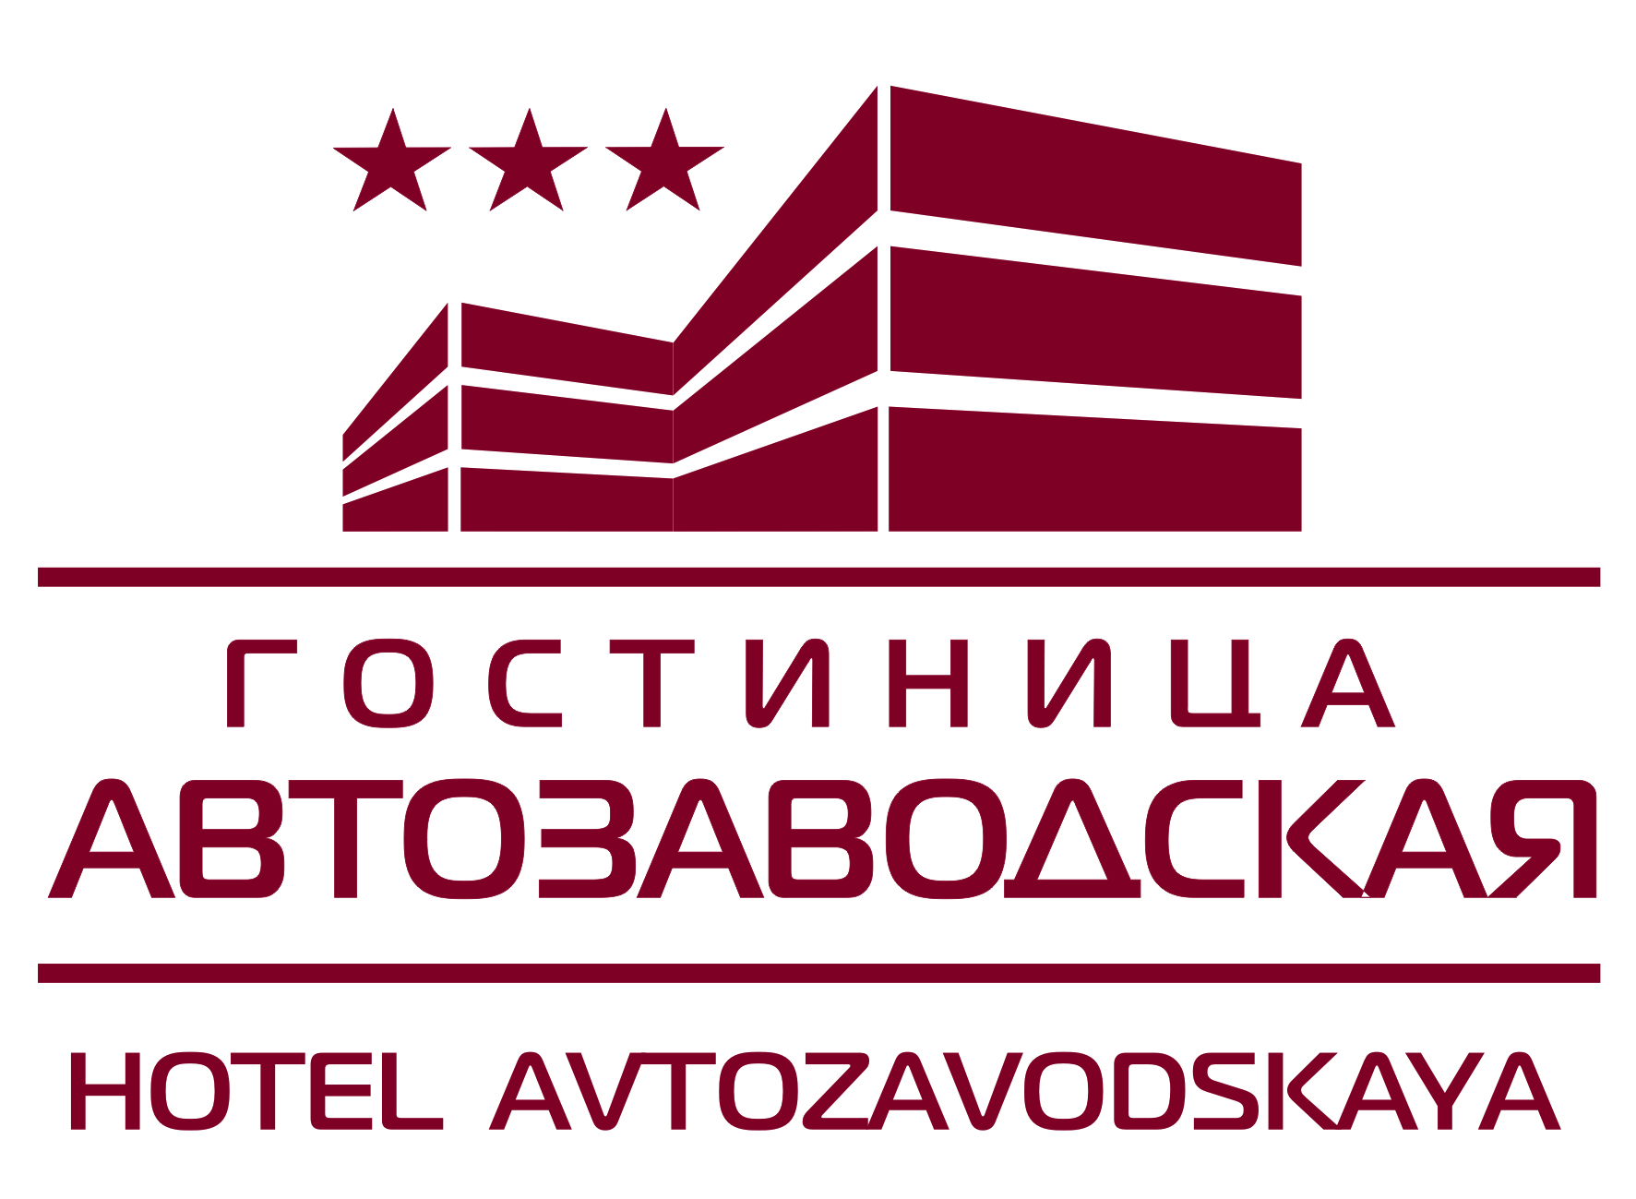
Terms of Reservation and Payment Procedure:
1. Reservation is made on the basis of application sent by e-mail avtozavod-hotel@avtozavodskaya.ru or by fax (831) 295-73-18, or filed on-line in website www.avtozavodskaya.ru.
2. The room is considered to be reserved when the guest gets the reservation confirmation.
- The guest may cancel or change the reservation details 24 hours before arrival.
- The check-in/check-out time in the Avtozavodskaya Hotel is 12:00 noon of local time (There is Moscow time in Nizhny Novgorod).
5. In case of checking-in from 12:00 noon till 12:00 midnight the payment for the first night is charged according to the check-in time. If the accommodation period is extended for one or more days, the check-out time is 12:00 noon.
6. Check-in before 14.00 is possible only if there are vacant rooms.
7. In case of early or late check-in the terms of payment are the following:
- check-in from 12:00 midnight till 06:00 a.m.- payment by hour of the room RACK rate is charged (till 12:00 noon);
- check-in from 06:00 a.m. till 12:00 noon no extra pay is charged.
- Staying at the hotel less than 24 hrs – the one night room rate is charged.
- In case of late check-out the extra pay is charged as follows (only if vacant rooms are available):
- 6 hours of delay after check-out time – payment by hour of the RACK rate;
- 6 to 12 hours of delay after check-out time – 50% of the RACK rate is charged additionally;
- 12 to 24 hours of delay after check-out time – 100% of the RACK rate.
10. For corporate and group reservations, please, call our Sales & Marketing Department at telephone (831) 295-77-77, 295-77-60.

